GOVERNMENT OF THE UNITED STATES VIRGIN ISLANDS
♦

PO Box 303159-Charlotte Amalie St. Thomas, VI 00803-3 I 59 (340)776-3700, Fax (340)714-4995

MEMORANDUM
Division of Unemployment Insura11ce Tax Unit

Date: To: Thru: Thru: Thru: Thro: From:
December 23, 2021

Gary Molloy, Commissioner of Labor

Jean A. Forde, Assistant Commissioner of Labor

Nesha Christian-Hendrickson, Assistant Commissioner/Legal Counsel Gary Halyard, Acting Unemployment Insurance Director
Veronica Grant, Unemployment Insurance Division, Assistant Director Faye Reed, Chief of Tax

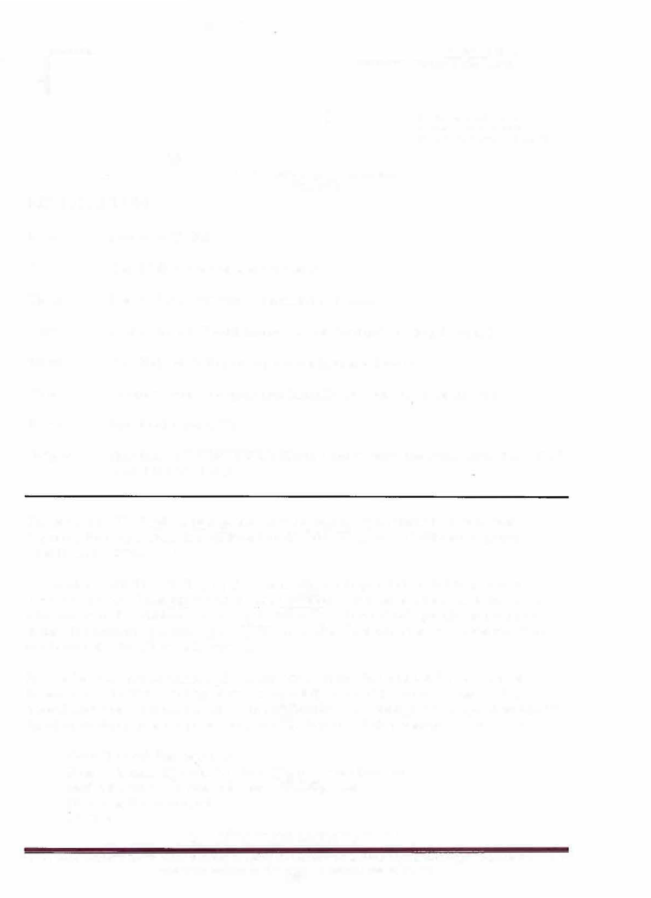
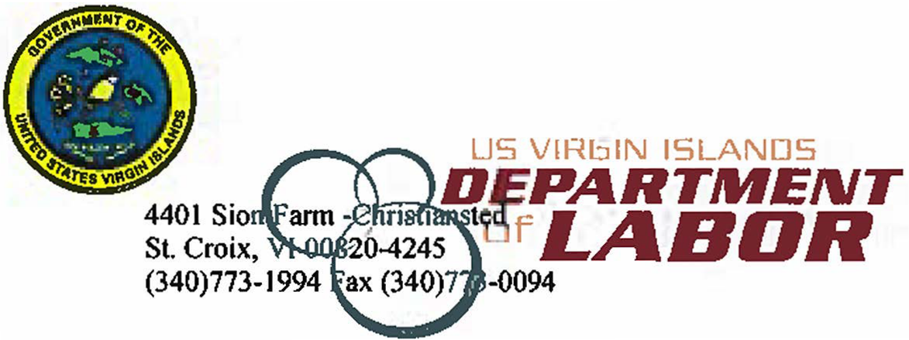
Subject: 2022 MAXIMUM WEEKLY BENEFIT AMOUNT (MWBA) AND TAXABLE WAGE BASE (TWB)

The Maximum Weekly Benefit Amount (MWBA) in the Vi_{rg}in Islands for benefit year beginning January 1, 2022, is $642.00 and the Taxable Wage Base (TWB) for employer contributions is $30,800.00.
In accordance with Title 24 Chapter 12, Section 303(c) of the Virgin Islands Unemployment Insurance Act, the Maximum Weekly Benefit Amount shall be an amount equal to sixty-five
(65) percent of the established Average Weekly Wage in insured work rounded to the next lower dollar. The established Average Weekly Wage based on employment and wage statistics from our Bureau of Labor Statistics is $986.93.
In accordance to Title 24, Chapter 12, Section 308(c). of the Virgin Islands Unemployment Insurance Act, the Taxable Wage Base is sixty (60) percent of the Average Annual Wage in insured work rounded to the nearest one hundred dollars. The established Average Annual Wage based on employment and wage statistics from our Bureau of Labor Statistics is $51,320.21.
cc: Gary Halyard, Director BLS
Rainia Thomas, Director Workers Compensation Division Melita Etienne: Director Workforce Development
UI Tax and Benefits Staff IT Staff
"Labor Works... Let Labor Work For You."

The Virgin Islands Department ofLabor Is an Equal Opportunity Employer with Equal Opportunity Programs. Auxlllary aids and services are available upon request to Individuals with disabilities.

